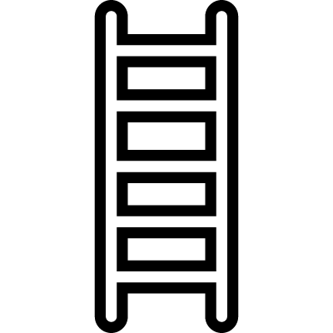
Evidence-Centered Classroom Assessment – Skill Rubric
Skill Name:

Description:

Height  Levels of  Performance | Description of Skill  What will students be able to do if they are demonstrating the skill? | Assignment Characteristics  What will show you that students have the skills you are looking for? | Activity Characteristics  What do students need to do in order to generate the required evidence?
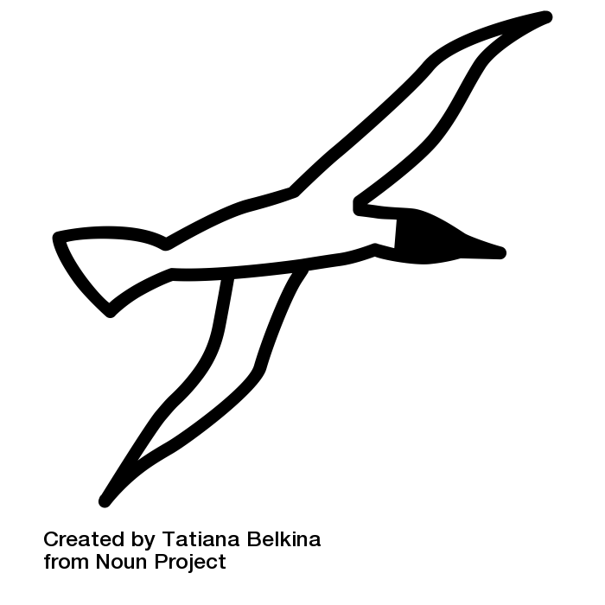 Advanced
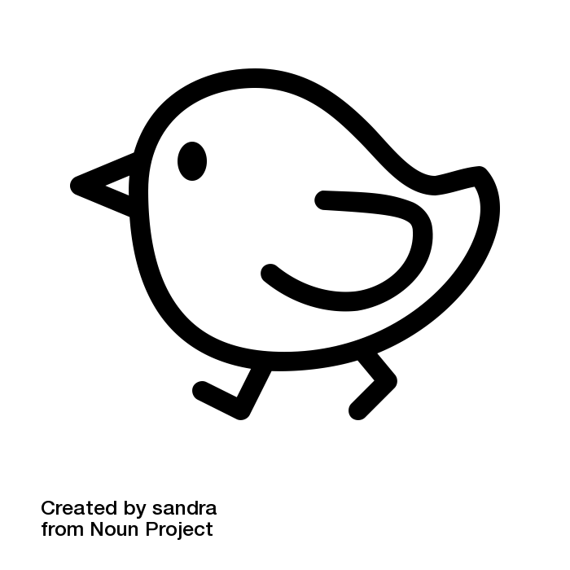
Proficient
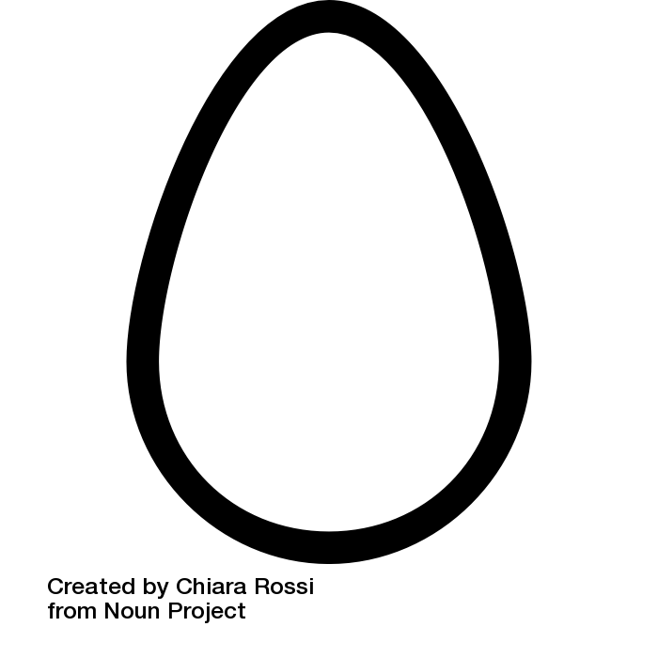 Approaching
Links to other skills:

Related Standards and Objectives:

